flyaway.com
Application Screenshots

Version History:
Author: | Anjali Bahadure
Purpose: | Screenshots of the application
Date: | 14 November 2021
Version: | 1.0

Table of Content:

Flight Booking: 3
Main Menu Screen Shot: 3
Flight Search: 3
Selecting Date of Travel: 4
Specifying Source, Destination and Number of Passengers: 4
List of available flights for the given criteria: 5
Adding first passenger’s details: 5
Booking Details: 6
Enter Payment Details: 7
Booking Confirmation: 8
Admin Login: 9
Provide admin credentials: 9
Application Administration Page: 10
Manage Users: 10
View all users: 10
Reset Password: 11
Add New User: 11
Manage Flights: 12
Edit flight details: 13
Add New Flight: 13
Add new flights details: 14
Manage Source/Destinations: 15
List of source/destinations: 16
Edit source/destination: 16
Add New Source/Destination: 17
Database Tables: 18
users 18
Source/Destinations: 19

Flight Booking:

Main Menu Screen Shot:

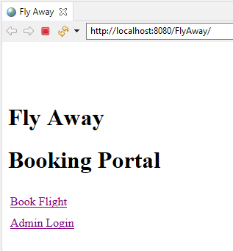

Flight Search:

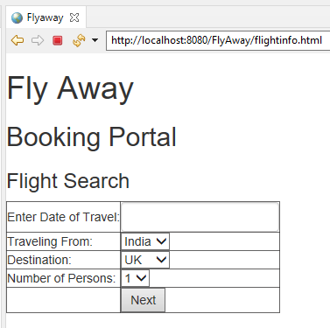

Selecting Date of Travel:
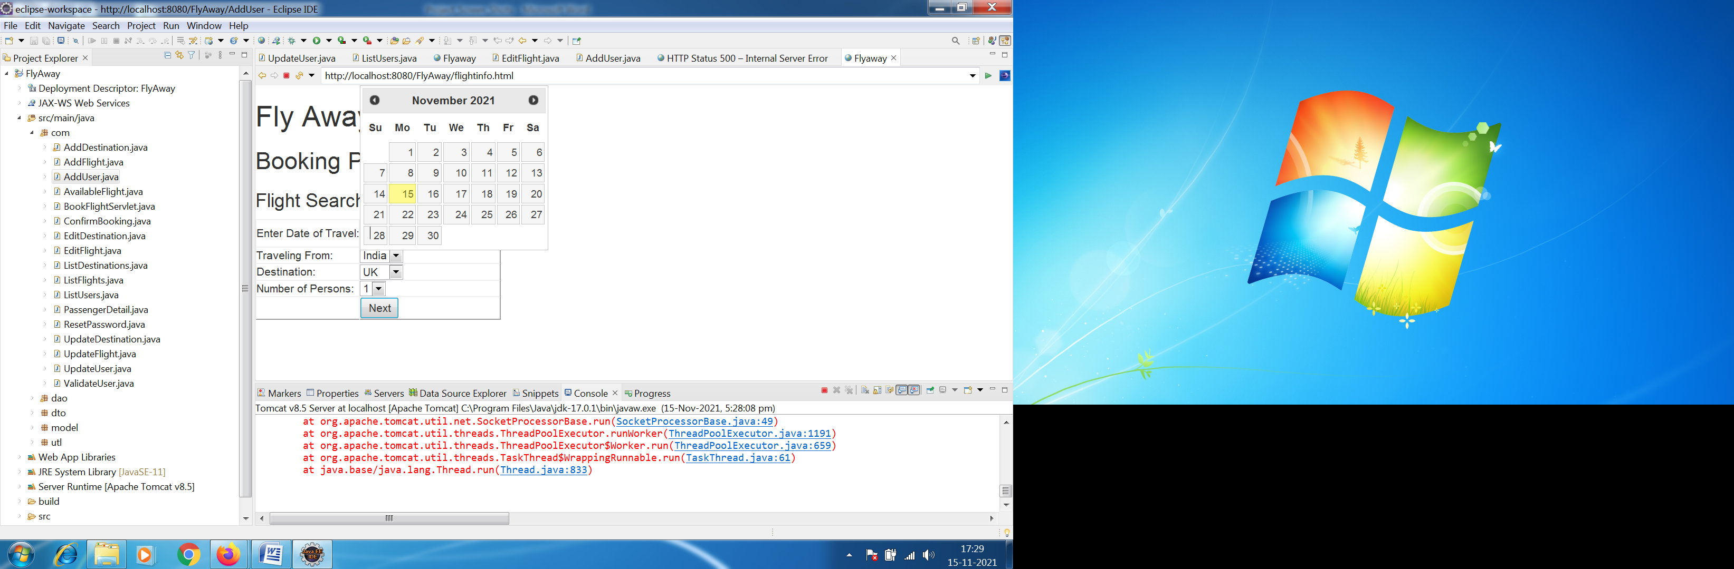

Specifying Source, Destination and Number of Passengers:
Click Next

List of available flights for the given criteria:
Select the suitable flight
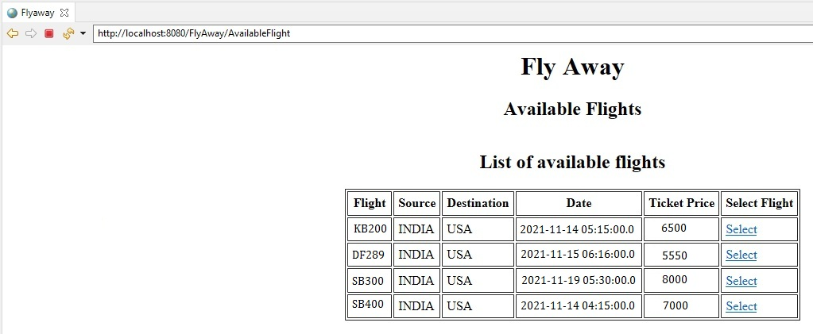

Adding first passenger’s details:
Click Add

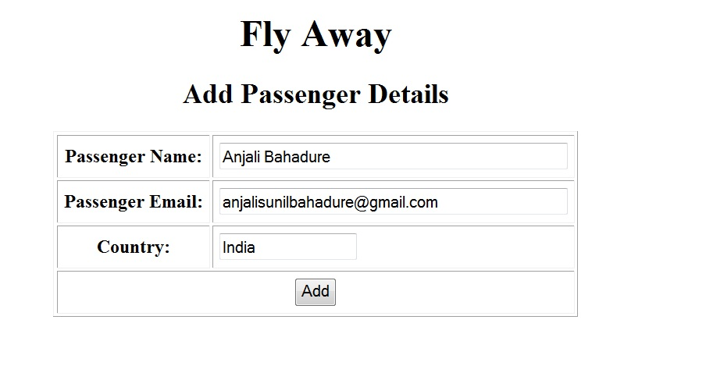

Booking Details:

PNR # generated
Flight, Passengers and Fare Details added
Click Payment to pay
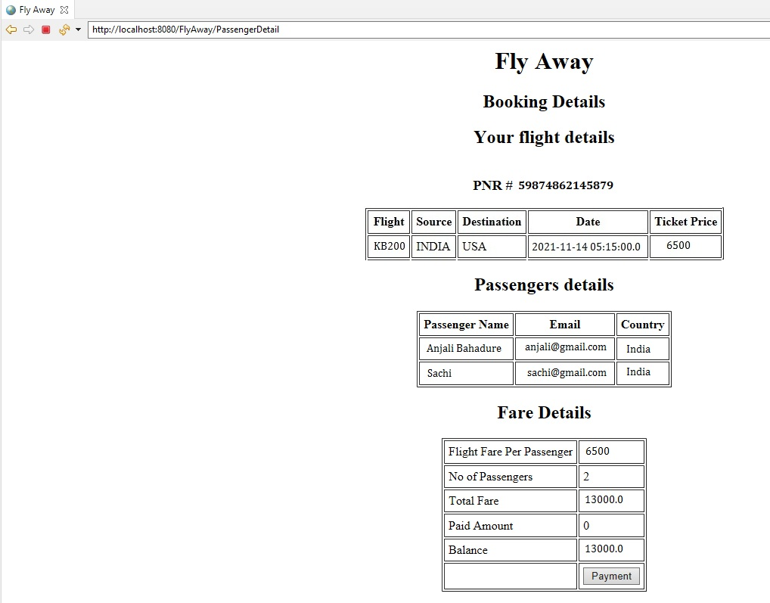

Enter Payment Details:
Click Pay
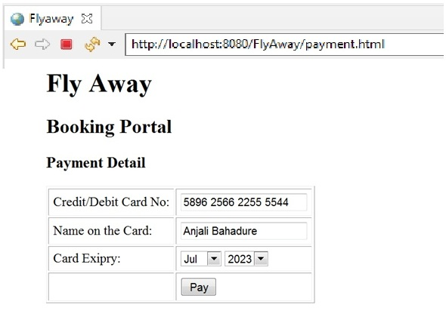

Booking Confirmation:

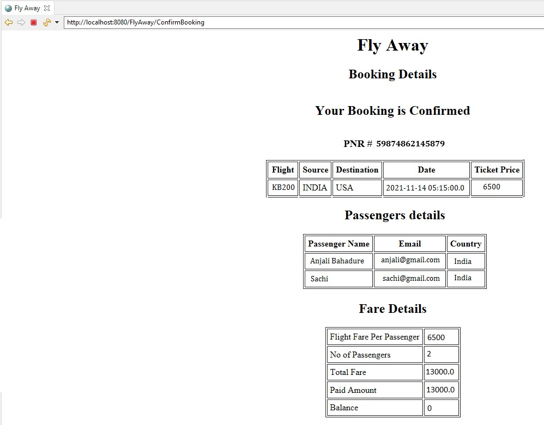

Admin Login:
Click on Admin Login

Provide admin credentials:
Provide username and password and click login (admin/admin)
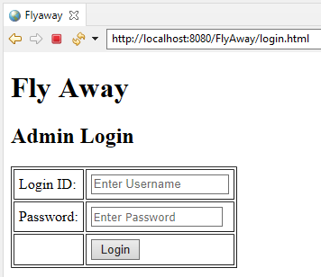

Application Administration Page:

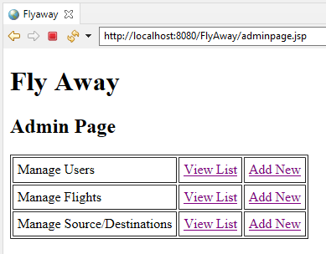

Manage Users:

View all users:
To reset user’s password, click on “Reset Password”
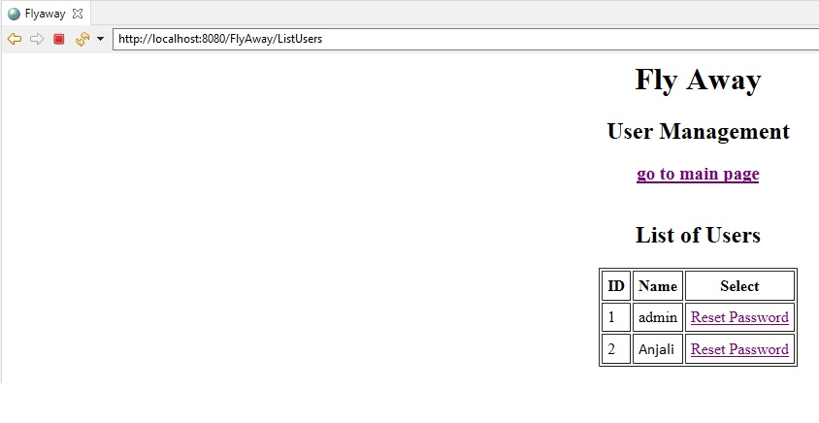

Reset Password:
Type new password and click “Reset Password”
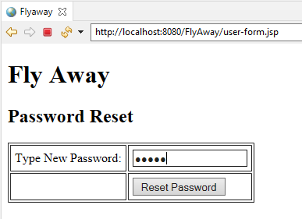

Add New User:
To add new user, click on “Add New”

Provide username and password, and click “Add”
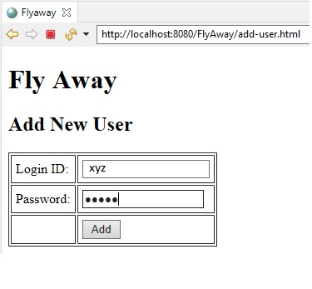

Manage Flights:

Edit flight details:
Modify the flight’s detail and click “Update”
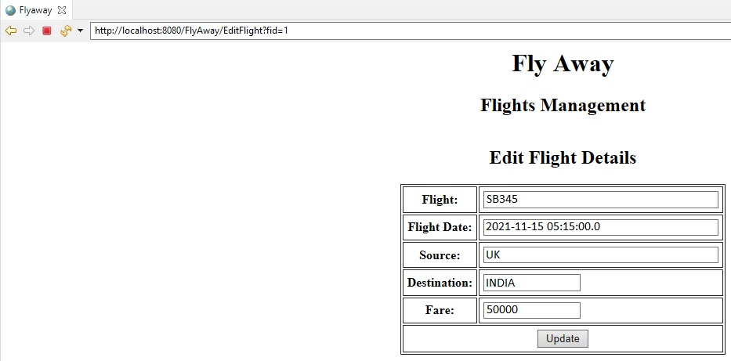

Add New Flight:
To add new flight, click on “Add New” for manage flights

Add new flights details:
Provide new flight’s details and click “Add”
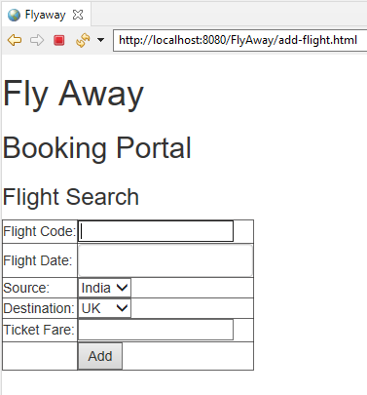

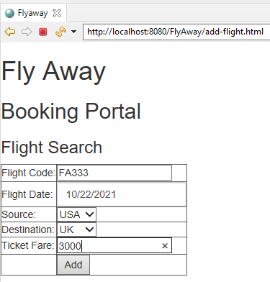

Manage Source/Destinations:

To view list of all source/destinations, click on “View List” for manage source/destinations

List of source/destinations:
To edit destination, click on “Edit”
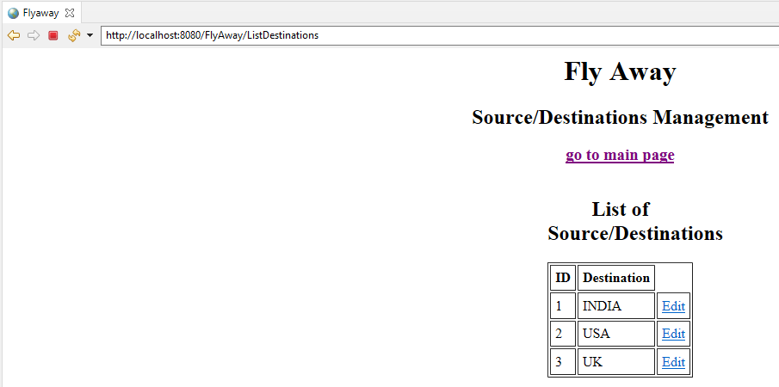

Edit source/destination:
Modify the source/destination and click “Update”
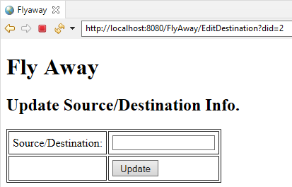

Add New Source/Destination:

To add new source/destination, click on “Add New” for Manage Source/Destinations
Click Add
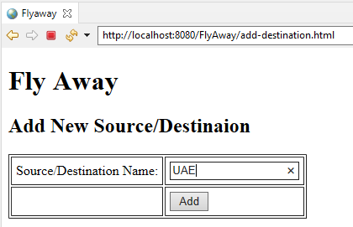

Database Tables:

users

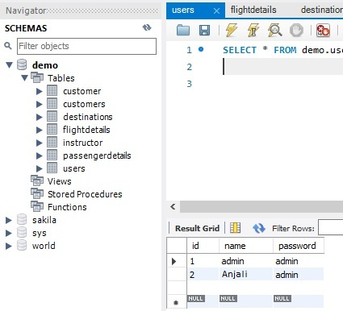

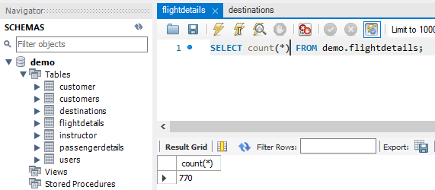

Source/Destinations:
